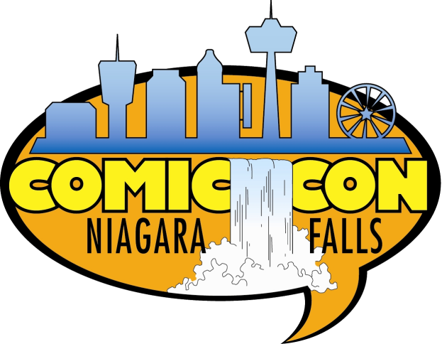

Niagara Falls Comic Con 2019 Volunteer Sign-Up Form

Full name: Email:

Phone: Date of birth:

Emergency contact: Emergency phone

Have you ever volunteered for Niagara Falls Comic Con before? Yes No If yes, what year? _

What duties have you done in past? T-shirt size:

Please check off the dates and times you are available. Please note that this does not guarantee that you will be assigned this date or time, (All day each day will be given first requests).

Friday | √ | Saturday | √ | Sunday | √
1 - 6pm |  | 8:30am- 2pm |  | 8:30am – 2pm
3- 8pm |  | 1pm – 6pm |  | 1pm – 6pm
ALL DAY |  | ALL DAY |  | ALL DAY
Please check off areas of interest: (Please note- Volunteer Positions are not guaranteed all positions are important for the success of the event, Thank you in advance for your support)
Job Title | √ | Job Title | √ | Job Title | √
Outdoor Line Control |  | Media Check in |  | Line Attendant
Hand Stamper |  | VIP Check in |  | Featured Artist Line
Ticket Taker |  | Hospitality |  | Q&A Room Monitor
Exit Door Monitor |  | Photo Op Area |  | Break Relief (All Areas)
Volunteer Registration |  | Runner |  | Celebrity Line Attendant
Terms and Conditions
In consideration of my desire to serve as a volunteer for Niagara Falls Comic Con Limited, I hereby assume all responsibility for any and all risk of bodily injury or property damage that I may cause or sustain while participating in any voluntary duties in relation to the Niagara Falls Comic Con event. I currently have no known mental or physical condition that would impair my capability for full participation as intended or expected of me and I am over the age of 16. Further, I understand that Niagara Falls Comic Con Limited does not assume any responsibility for or obligation to provide me with any financial, medical, health, or disability benefits or insurance of any nature in the event of my injury, illness, death, or damage of my property in the event of such injury or medical expenses incurred by me. I also forever discharge Niagara Falls Comic Con Limited from any claim whatsoever which arises or may hereafter arise on account of any first-aid treatment or other medical services rendered in connection with an emergency during my tenure as a volunteer. I hereby grant all rights to any and all photographs, images, video and audio recordings of me or my likeness made by Niagara Falls Comic Con Limited to also be the property of Niagara Falls Comic Con Limited for their use for promotional purposes. By signing below, I express that I have read the above terms and conditions. It is my understanding and intent to enter into this release and waiver of liability willingly and voluntarily.
Signature: Date:
Print Name:

